**Data insertion using postman**

If you have web api endpoint for insertion then go the body section of it

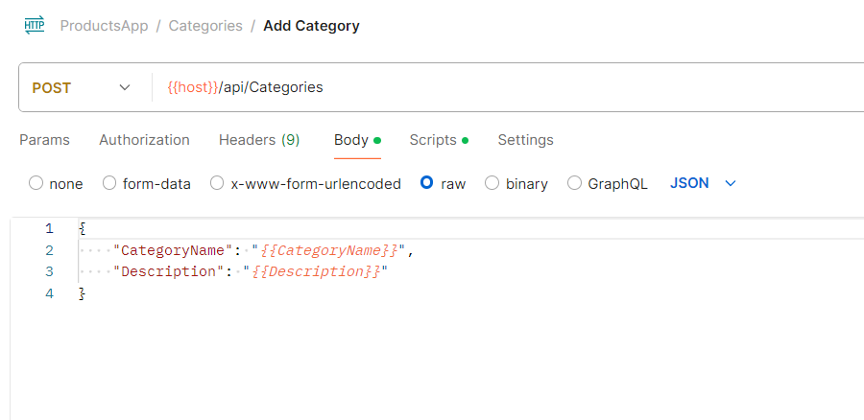

Here you need to add variable name for each property.

Now go to the collection and click on three dots.

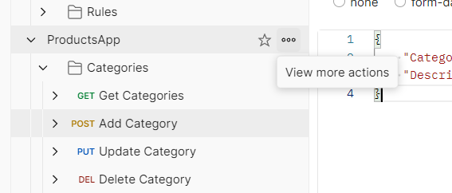

Now click on run collection option

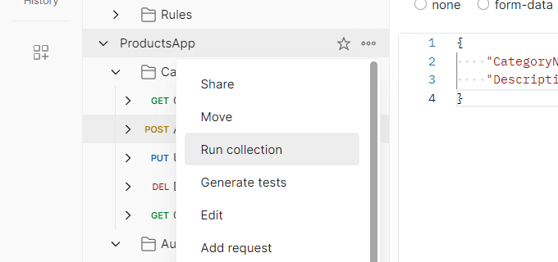

Here you can select post request were you want insert data.

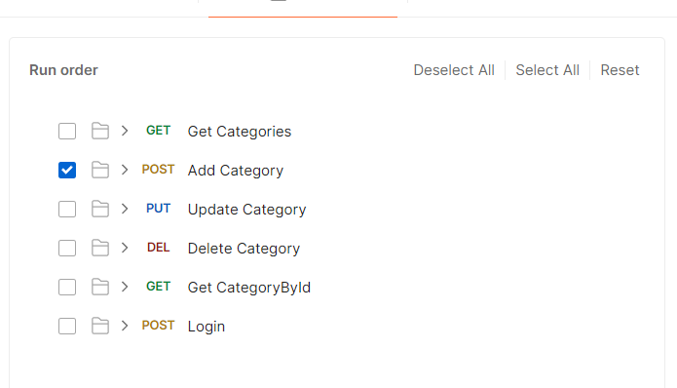

Now you need to select data were you will select json file which has json array that you want to insert

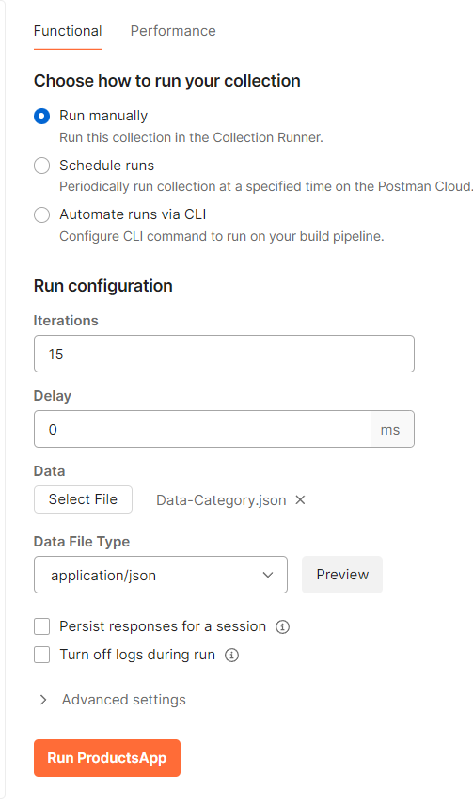

After selecting it hit run button and it will insert all data.